Scenario 1: Aws organization invite other AWS account to main account.
Your organization has 2 Datacenter (one in Mumbai and one in virginia regions).
Mumbai region is managed by account – 277707115759
Virginia region is managed by account – 669155638206
Now instead of managing different accounts individually and billing also.
You plan to combine and manage this both accounts.

Solution: we can use organization, and you invite another account to club and use the resources.
Steps to invite Virginia region account to club with Mumbai region account.
Step 1: Navigate to AWS organization, select Add an AWS account.
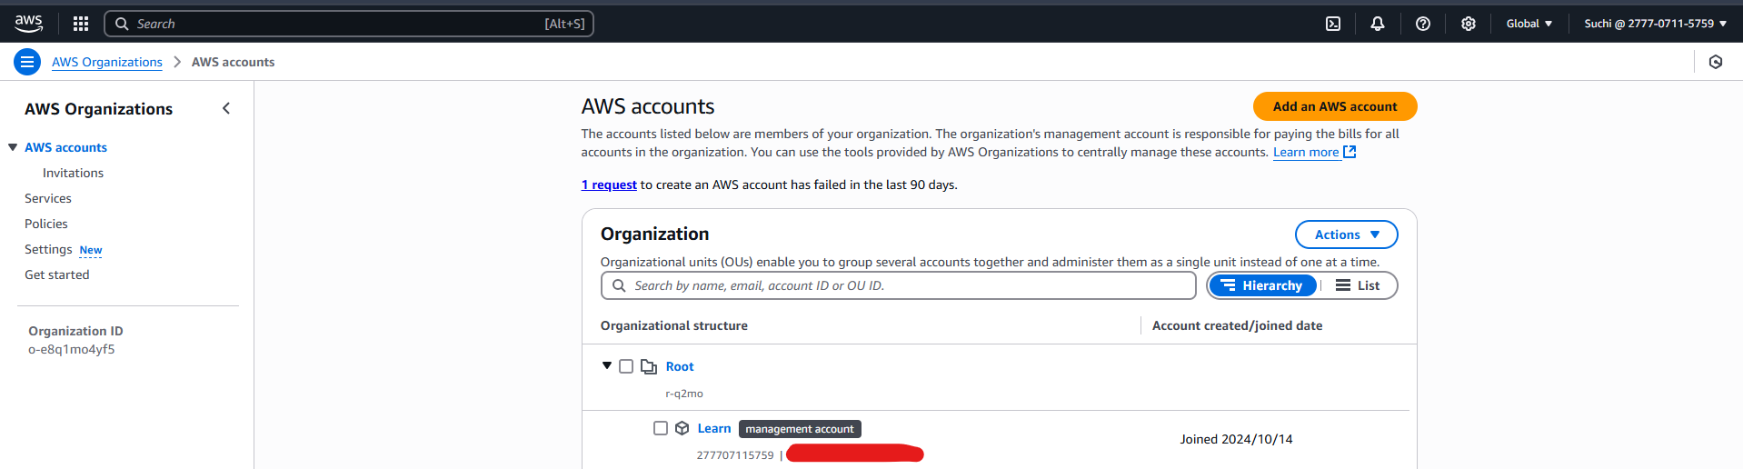
Step 2: select invite an existing AWS account and provide an virginia account Id.
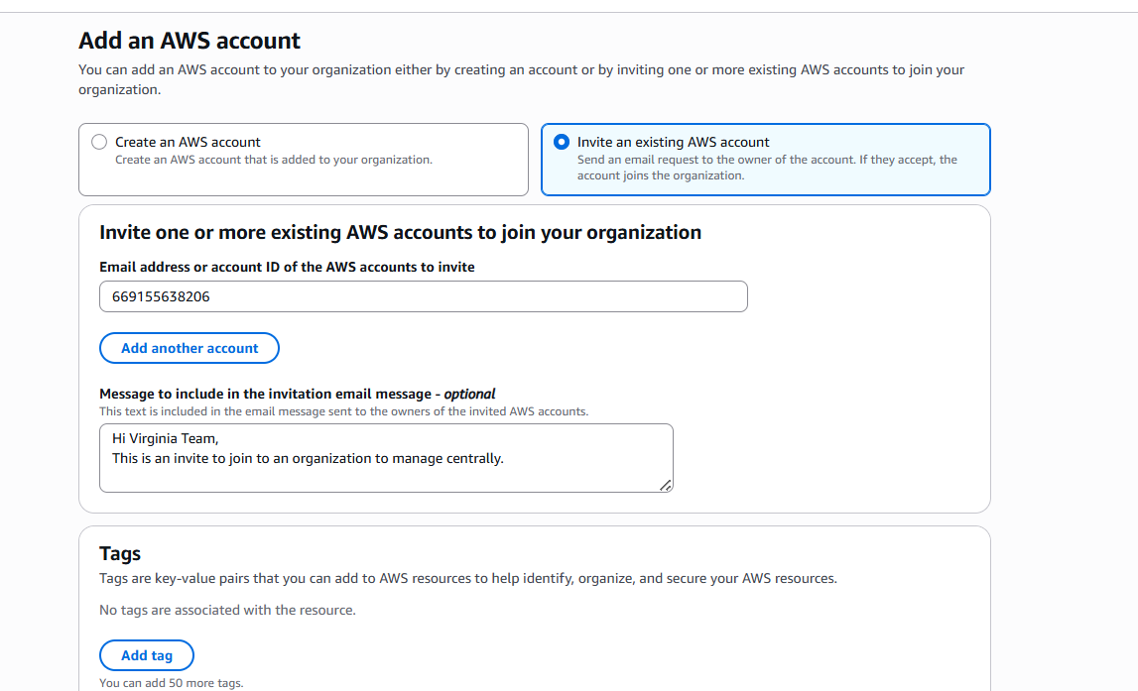
Step 3: once the invitation is sent. Ask to the virginia account holder to accept the invitation
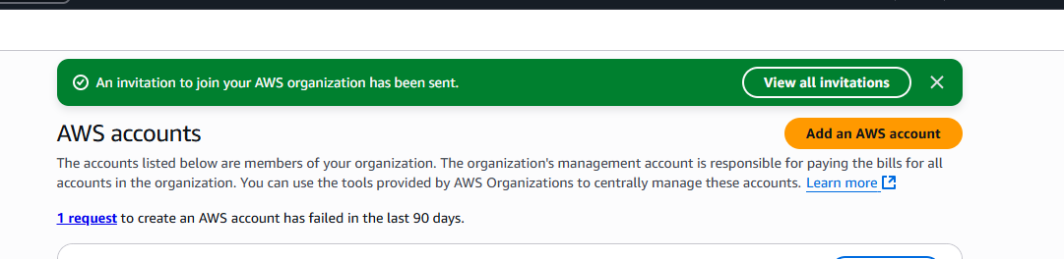
Step 4:
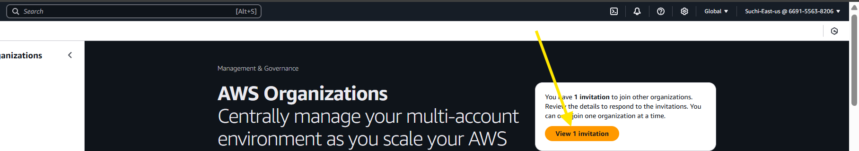
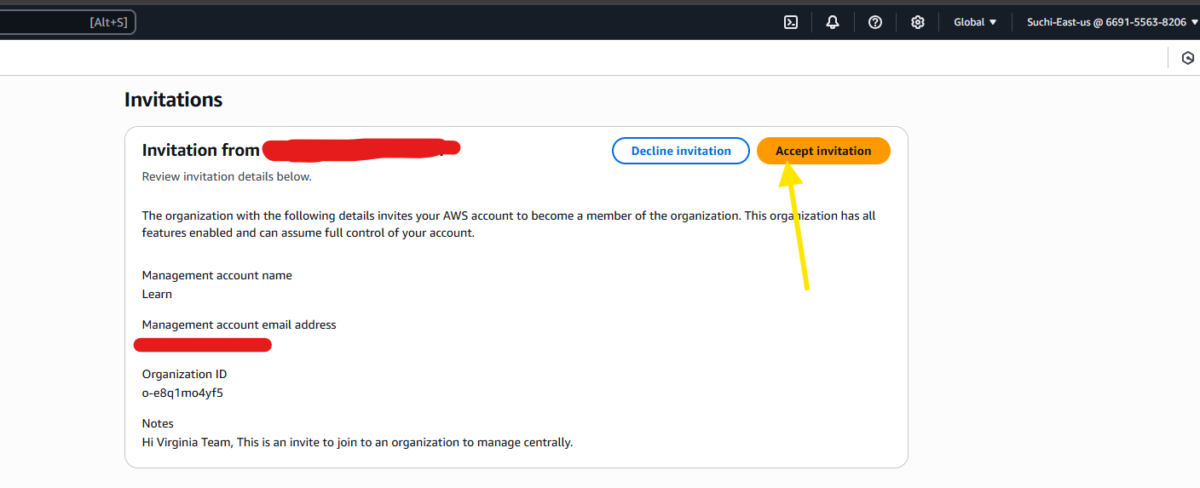
It will be populated in your aws organization.
Note: when we try to consolidate or inivte other accounts to organization. We need to ensure that this both AWS account was created under a same billing model (seller of record).
If both accounts are different then you will face the below error
